LEVERHULME TRUST DOCTORAL SCHOLARSHIPS
UNDERSTANDING MARITIME FUTURES: OPPORTUNITIES, CHALLENGES, THREATS

GUIDANCE AND PROJECT DESCRIPTION FORM
2015

Scheme Outline:

The Leverhulme Trust has awarded Southampton Marine and Maritime Institute 15 fully-funded PhD grants, with the first 5 scholarships to commence in October 2015. The scholarships will be funded for 3 years at RCUK levels and each will include full-time UK/EU fees. The focus of the scheme is on matching the best possible candidates to the most innovative and interesting projects. As such, matching or part-funding from University faculties, external partners, and stakeholders is not a requirement for these scholarships, but would help demonstrate commitment to and support for the project. It is recognised that some academic units and faculties will not be able to provide match funding but extra monies will be used to increase the cohort size through underwriting additional scholarships.

SMMI Understanding Maritime Futures Leverhulme Trust Doctoral Scholars will address key global issues such as such as access to resources, safety and security, the effects of rising sea levels, technical advancements and autonomy, our responses to natural and human disasters, the impacts on people, and the ways people living by and from the sea understand their experiences and cultural heritage. The vision for the programme is to develop transdisciplinary thought leaders and researchers who have a unique human-centred approach to understanding, living, and working with the sea. The programme aims to facilitate a different, more creative and holistic way of problem solving to address marine and maritime societal challenges.

The programme particularly encourages projects that:
- propose a transdisciplinary approach to tackle an important societal challenge in the marine and maritime realm;
- are useful in informing national and international decision makers from government, business and civil society;
- have direct benefit to marine/maritime stakeholders such as port authorities, aid and/or government agencies, businesses, seafarers and coastal communities;
- challenge public understanding and/or capture the public imagination.

SMMI members are invited to propose transdisciplinary projects that tackle major maritime issues. It is expected that the cohort of PhD students will provide the core of an expanding and integrated knowledge basis which will assist with the pressing maritime issues of the future. The enduring legacy of Leverhulme Trust investment in our PhD graduates will be a new type of highly employable research leader.

The application process has two stages.

Stage 1: Provisional Selection of Projects. The Maritime Futures LTDS Steering Committee (led by Prof. Damon Teagle, SMMI Deputy Director for Research) will shortlist projects to be taken forward to Stage 2.

Stage 2: Recruitment of Candidates and Final Selection of Projects. At least 5 scholarships will be awarded to start in October 2015. Academic excellence of individual doctoral candidates and their fit with the proposed project will be the principal driver for selection. We seek excellent (usually 1st Class Masters-level qualification) polymath candidates with the abilities and desires to move beyond their undergraduate disciplinary knowledge into other fields to be better able to tackle important societal challenges that require a range of skills and experience. This could involve a physical scientist, life scientist or engineer developing an understanding of legal, psychological, economic, or social science concepts and practices, or a humanities scholar acquiring a technical understanding of climate change and developing the numerical, statistical, geographic information or computational skills. PhD students will be recruited through open competition using a Proposal Challenge and interview. For the Proposal Challenge candidates will submit a ~1500 word response to a topical maritime issue confronting society, for example “What key principles should be considered for the future use of seabed mineral resources in the deep ocean?” or “What policy developments are required to make the oceans and seas ‘an enabling environment for development for the benefit of all’ (United Nations Development Strategy Beyond 2015)?”.

Timelines:
20 January 2015 – 16 February 2015: | Maritime Futures LTDS Steering Committee will receive completed application forms from SMMI Members.
16 February 2015 – 23 February 2015: | Maritime Futures LTDS Steering Committee will review applications and shortlist10 projects.
23 February 2015 – 30 March 2015 | Recruitment of candidates through completion of Proposal Challenge.
31 March 2015 - 10 April 2015 | Maritime Futures LTDS Steering Committee will review applications and select candidates for interview.
27/28 April 2015 | Candidates will be interviewed by Maritime Futures LTDS Steering Committee and supervisory teams.

Application Criteria:
To register a potential project for consideration, the attached application form should be completed and submitted by 5pm 16 February 2015. Supervisory teams will be notified if their project has been selected for stage 2 by 23 February 2015.

The application form must contain the following information:
- Project title
- Names of all supervisors and their Faculty/Academic Unit.
- Proposal of Maritime Futures research project (approximately 1000 words) to include:
- The project’s relevance to the Scheme Outline and its transdisciplinary nature
- Rationale
- Methodology
- Training
- Details of external partners and their input to the project.
- Wider implications, impact, and future funding potential.
- A short (2 page) CV of each member of the supervisory team including recent publications and funding.
- A budget outlining ALL research costs.

Selection Procedure:
Applications will be reviewed by Maritime Futures LTDS Steering Committee, led by Prof. Damon Teagle. The review will examine:

- Excellence of project.
- Transdisciplinary nature of the project and fit with Scheme Outline.
- Excellence of supervisory team and external collaborators.
- Impact and future funding potential.
- Access to additional funding.

Conditions and Reporting:
Teams awarded LTDS funding will be required to:
- Agree a lead supervisor who will be the main contact and whose Faculty Finance Team will liaise with SMMI regarding the transfer of funds.
- Contribute to the Maritime Futures LTDS Training Programme. Minimum requirement will be the delivery of a research paper in the Lloyds Register-SMMI Seminar Series.
- Produce a report at the end of each academic year for the Maritime Futures LTDS Steering Committee. This report will be due on 1 August each year and must include a review of challenges and successes, projected goals for the forthcoming year and document related abstracts, papers, and grant proposals.
- Include an acknowledgment of The Leverhulme Trust support on all publications and posters resulting from this award.

LEVERHULME TRUST DOCTORAL SCHOLARSHIPS
UNDERSTANDING MARITIME FUTURES: OPPORTUNITIES, CHALLENGES, THREATS
PROJECT DESCRIPTION FORM
2015

Please complete the form below and submit to Sue Smith, SMMI Co-ordinator, at s.b.smith@soton.ac.uk by the application deadline of 5pm 16 February 2015. All criteria should be met as set out in the attached guidelines.

Research Project Title:

SMMI-LTDS PROJECT SUPERVISORY TEAM DETAILS:
SMMI Member Name (1):
Faculty & Academic Unit:
Email:
SMMI Member Name (2):
Faculty & Academic Unit:
Email:
SMMI Member Name (3):
Faculty & Academic Unit:
Email:
External Supervisor Name (1):
Organisation and position:
Email:

SMMI-LTDS Understanding Maritime Futures STUDENTSHIP DETAILS 2015/16:
Studentship Start Date: | October 2015
Please attach:
• A two page CV including recent publications and funding for each Supervisor.
Rationale (max. 300 words):
Project’s transdisciplinary nature and relevance to the Understanding Maritime Futures LTDS Programme (max. 200 words):
Methodology (max. 200 words):
Training (max. 200 words):
Details of external partners and their input to the project (max. 150 words):
Wider implications, Impact, and future funding potential (max 150 words):
Background reading (max. 3 references):
Details of Additional Funding or Support:
Understanding Maritime Futures
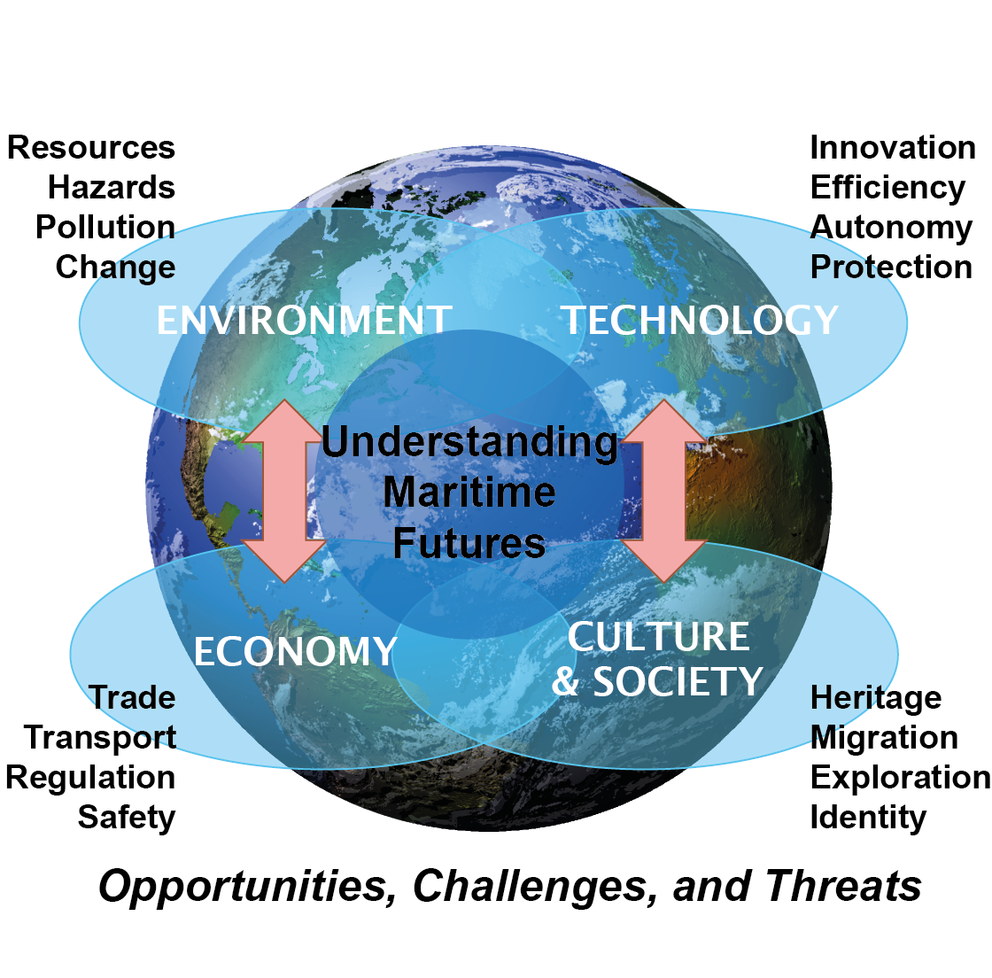
P.I. Signature | Signature: …………………………………………………  Date: ………………………………………………………

Faculty authorising signature  (e.g. Associate Dean for Research /Director of Graduate School) | Signature: …………………………………………………  Date: ………………………………………………………

Please return completed application forms by 5pm 16 February 2015 to Sue Smith at s.b.smith@soton.ac.uk. Southampton Marine & Maritime Institute, Building 176, Room 3043,
Boldrewood Campus, Tel: 023 8059 2316; http://www.southampton.ac.uk/smmi

Colleagues can request to become members of SMMI by contacting S.B.Smith@soton.ac.uk

